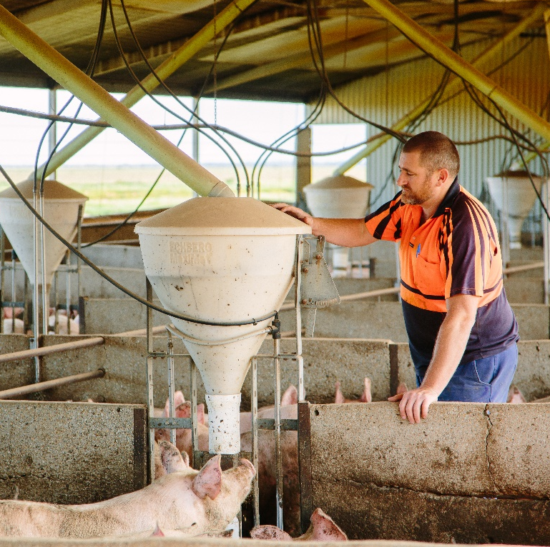
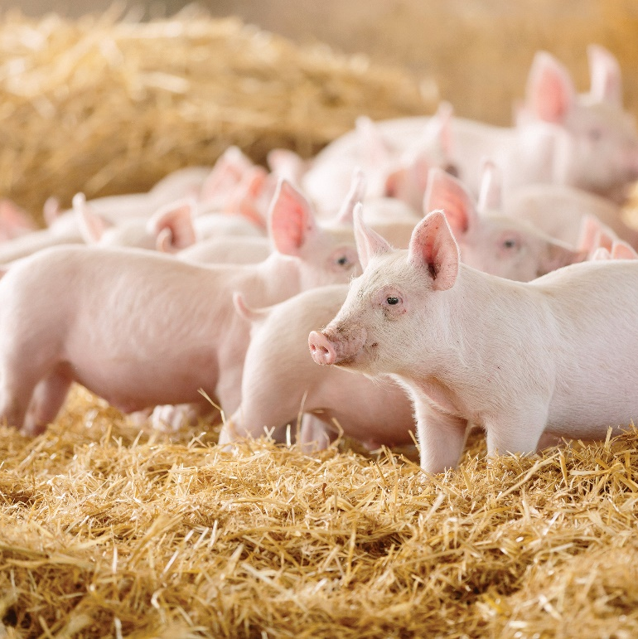

Request for proposal
A Benefit Cost Analysis for Base Funded Research
November 2023 - Australian Pork Limited

Request for proposals

Project objective – to determine the benefits to industry of the use of Base Funded Research Facilities
Australian Pork Limited (APL) is the national representative body for Australian pig producers. APL is a producer-owned not-for-profit company combining marketing, export development, research, innovation, and strategic policy development to assist in securing a profitable and sustainable future for the Australian pork industry. It is one of 15 rural research and development corporations (RDCs) providing research to Australian agriculture.
Funded by pig farmers, APL is paid to do what farmers can’t do for themselves. This includes:
- Building demand for pork meat products
- R&D to reduce costs, improve product quality and value chain efficiency
- Interaction with government on farmers’ behalf
Background
The base funding model for Research & Development (R&D) in the pig industry was initiated in 2009/10. The intent of base funding is to retain access to infrastructure, facilities and technical capability. Some base funded facilities are commercial pig operations, while others are research institutes primarily for the conduct of production related R&D. APL invests significantly each year to secure access to research facilities through base funding. The intent of base funding arrangements with core R&D providers has been to support a vast number of R&D projects over many years through securing the availability of infrastructure and technical capability, whilst also helping to contain project costs.
The facilities currently, as at Financial Year (FY) 2024 being funded by APL through this funding model include Rivalea (Australia) Pty Ltd, SunPork Consolidated Pty Ltd and the South Australian Research and Development Institute (SARDI), but have in the past also included The University of Melbourne, Pork Innovation Western Australia (PIWA) and SunPork North and SunPork South campuses as individual entities.
Primarily, R&D using base funded facilities has been in the cost of production area but has also been used more recently for research relevant to eating quality.
Current project
APL is seeking proposals to conduct a benefit cost analysis to determine what impact APL’s investment to base funded facilities has for the pork industry. To be more relevant to today’s market, it is proposed that the project looks at R&D investments conducted over the last four years (FY20 – FY23) up to 20 research projects. This should be undertaken with the understanding that the cost of a Research Equivalent will increase from $80,000 to $88,000from FY25, and how this increase will impact value and overall industry benefit going forward.
Over the last four years APL have invested between $424,000 and $744,000 annually across numerous R&D projects.
The project should address the following questions:
- What is the financial benefit in using base funded facilities as opposed to non base funded facilities (this will include using the same research facility with research funded outside of the base funding model)?
- How does the use of base funding impact on availability of the facilities and its resources? ​
- Does the use of base funded facilities provide more timely and relevant outcomes for industry?​
- Does the use of base funded facilities impact the sharing and adoption of R&D outcomes? ​
- Is there a more cost-effective model that could be considered?

Research Purpose
Project objective
- Determine the effectiveness and efficiencies to industry through the use of base funded facilities for research​
- Determine if the use of base funded facilities is the best model for the pig industry
- Possibly identify a model which could provide better leverage and outcomes for industry

Timeline
Date | Activity
22/12/2023 | Applications open
31/01/2024 | Applications close 5pm
14/02/2024 | Notification of proposal review outcome
20/02/2024 | Issue of Provider Agreement for successful applications and commencement of project
On execution of the agreement | APL provide relevant project materials for background information
21/06/2024 | Project completion
How to make a submission
Proposals should be provided electronically to:
Marzio.magistrelli@australianpork.com.au
Rebecca.athorn@australianpork.com.au
Research@australianpork.com.au
Contact
If you are interested in submitting an application, please contact:
Marzio Magistrelli
Business Innovation Director
0466 515 830
marzio.magistrelli@austrailanpork.com.au

Level 2, 2 Brisbane Avenue Barton ACT 2600
PO Box 4746 Kingston ACT 2604 Australia

T 02 6285 2200
F 02 6285 2288
Australian Pork Limited

